Data Visualization Tasks Report
Python Code & Output Graphs across All Tasks
Task 1: Hospital Patient Admission Analysis
1. Python Code
import numpy as np
import pandas as pd
import matplotlib.pyplot as plt
import seaborn as sns
# Synthetic Hospital Data Generation
np.random.seed(42)
departments = ['Cardiology', 'Neurology', 'Pediatrics', 'Orthopedics', 'Emergency']
months = ['Jan', 'Feb', 'Mar', 'Apr', 'May', 'Jun', 'Jul', 'Aug', 'Sep', 'Oct', 'Nov', 'Dec']
data = []
for m in months:
for dept in departments:
base_lam = {'Cardiology': 110, 'Neurology': 75, 'Pediatrics': 90, 'Orthopedics': 65, 'Emergency': 140}[dept]
admissions = np.random.poisson(lam=base_lam)
data.append({'Month': m, 'Department': dept, 'Admissions': admissions})
df_hospital = pd.DataFrame(data)
# 1. Bar Chart: Department Workload Overall
plt.figure(figsize=(7, 4))
dept_totals = df_hospital.groupby('Department')['Admissions'].sum().reset_index()
sns.barplot(data=dept_totals, x='Department', y='Admissions', palette='crest')
plt.title('Total Patient Admissions by Department (Overall Workload)')
plt.ylabel('Total Admissions')
plt.tight_layout()
plt.show()
# 2. Stacked Bar Chart: Monthly Workload Breakdown
pivot_hosp = df_hospital.pivot(index='Month', columns='Department', values='Admissions').loc[months]
pivot_hosp.plot(kind='bar', stacked=True, figsize=(8, 4.5), colormap='Set2')
plt.title('Monthly Hospital Patient Admissions by Department')
plt.ylabel('Number of Admissions')
plt.legend(title='Department', bbox_to_anchor=(1.02, 1), loc='upper left')
plt.tight_layout()
plt.show()
# 3. Box Plot: Admission Variability Across Months
plt.figure(figsize=(7, 4))
sns.boxplot(data=df_hospital, x='Department', y='Admissions', palette='Pastel1')
plt.title('Patient Admission Variability Across Departments')
plt.ylabel('Monthly Admissions')
plt.tight_layout()
plt.show()

2. Output Images
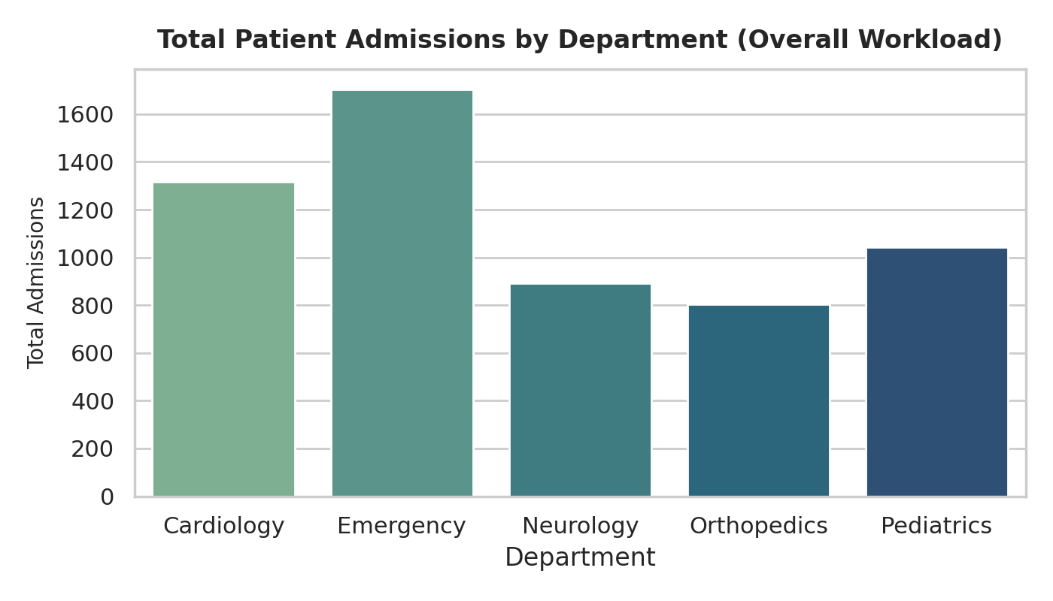
Figure: Task 1 - Overall Workload Bar Chart by Department
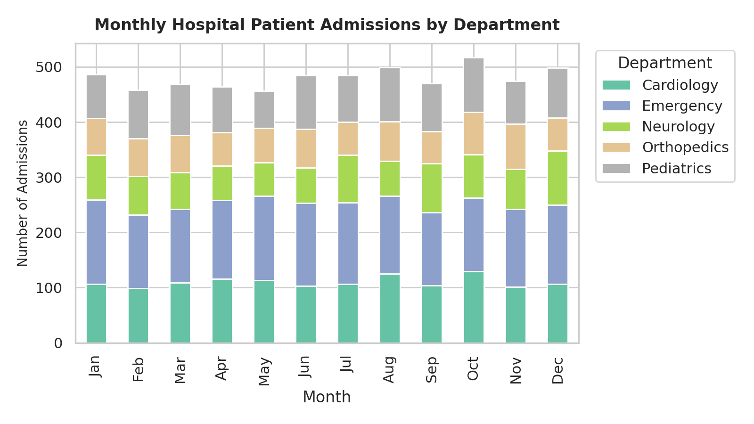
Figure: Task 1 - Monthly Stacked Bar Chart showing Patient Distribution
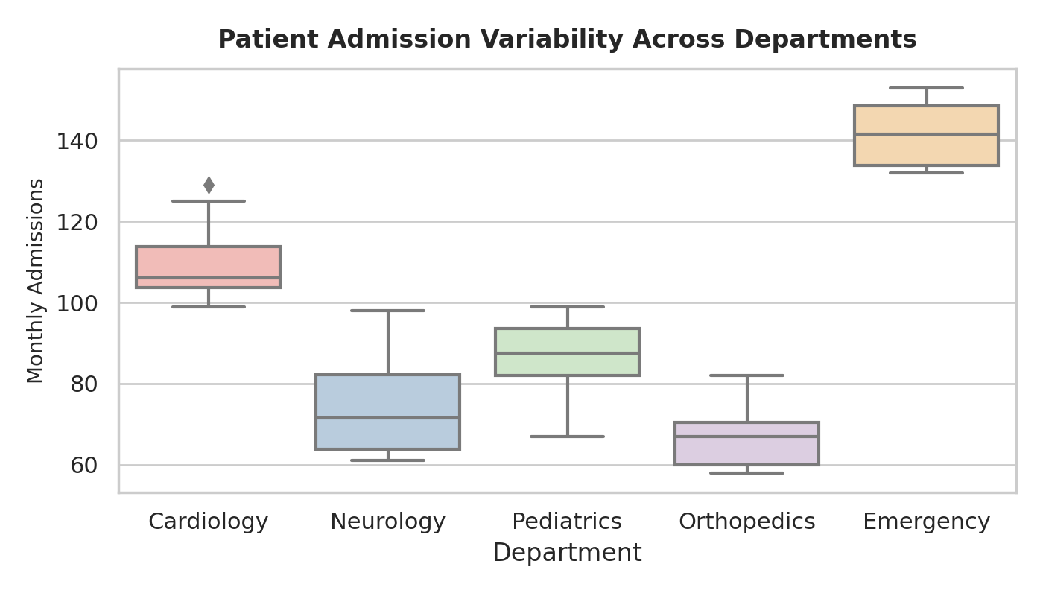
Figure: Task 1 - Box Plot showing Admission Variability across Departments
Task 2: E-Commerce Customer Spending Behaviour
1. Python Code
import numpy as np
import pandas as pd
import matplotlib.pyplot as plt
import seaborn as sns
# Synthetic E-Commerce Spending Data
np.random.seed(42)
n_cust = 500
categories = ['Electronics', 'Apparel', 'Home & Kitchen', 'Books', 'Beauty']
df_ecom = pd.DataFrame({
'CustomerID': range(1, n_cust + 1),
'Category': np.random.choice(categories, n_cust),
'PurchaseAmount': np.random.exponential(scale=120, size=n_cust) + 15,
'OrderFrequency': np.random.randint(1, 25, size=n_cust)
})
# 1. Violin Plot: Spending Distribution & Shape per Category
plt.figure(figsize=(7.5, 4))
sns.violinplot(data=df_ecom, x='Category', y='PurchaseAmount', palette='Set2', inner='quartile')
plt.title('Spending Variability by Product Category (Violin Plot)')
plt.ylabel('Purchase Amount ($)')
plt.tight_layout()
plt.show()
# 2. Box Plot: High-Value Customer Outliers
plt.figure(figsize=(7.5, 4))
sns.boxplot(data=df_ecom, x='Category', y='PurchaseAmount', palette='Set3')
plt.title('High-Value Customer Outliers by Category (Box Plot)')
plt.ylabel('Purchase Amount ($)')
plt.tight_layout()
plt.show()
# 3. Density Plot (KDE): Comparative Probability Density
plt.figure(figsize=(7.5, 4))
sns.kdeplot(data=df_ecom, x='PurchaseAmount', hue='Category', common_norm=False, fill=True, alpha=0.25)
plt.title('Customer Spending Density Distribution across Categories')
plt.xlabel('Purchase Amount ($)')
plt.tight_layout()
plt.show()

2. Output Images
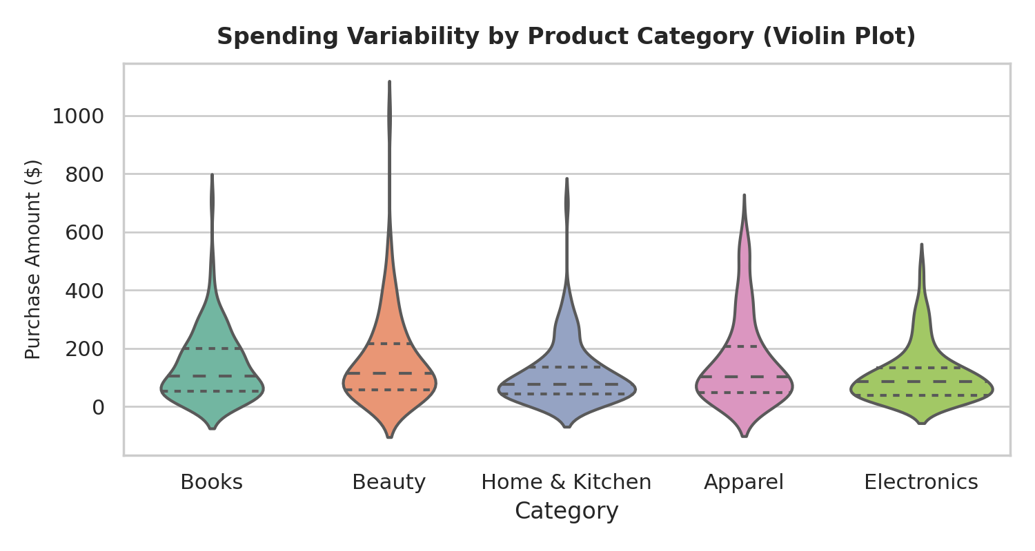
Figure: Task 2 - Violin Plot of Customer Spending Variability by Category
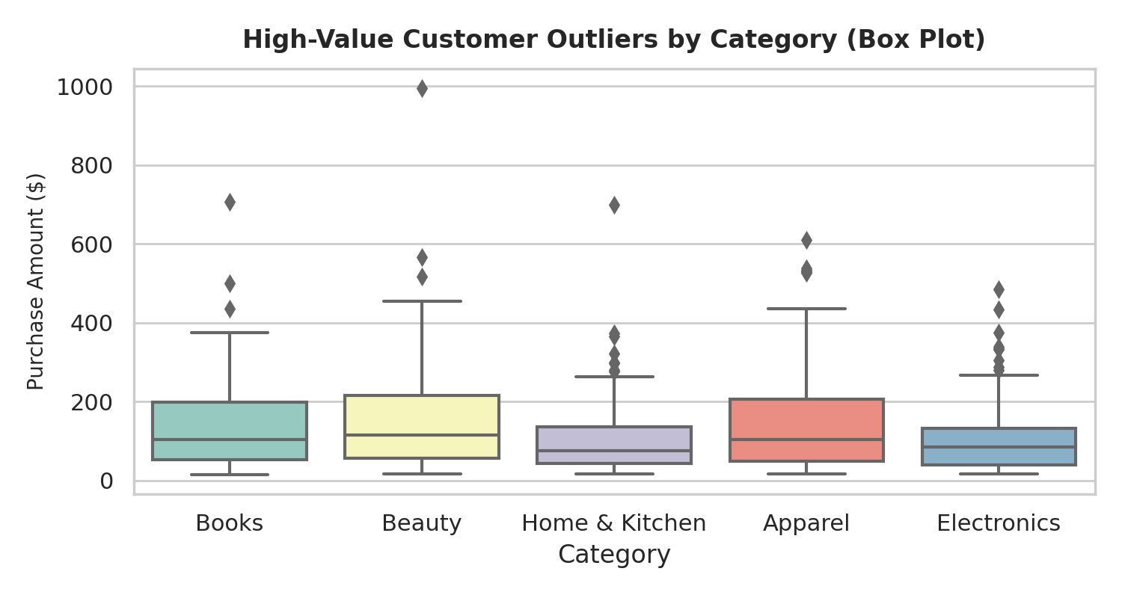
Figure: Task 2 - Box Plot Highlighting High-Value Customer Outliers
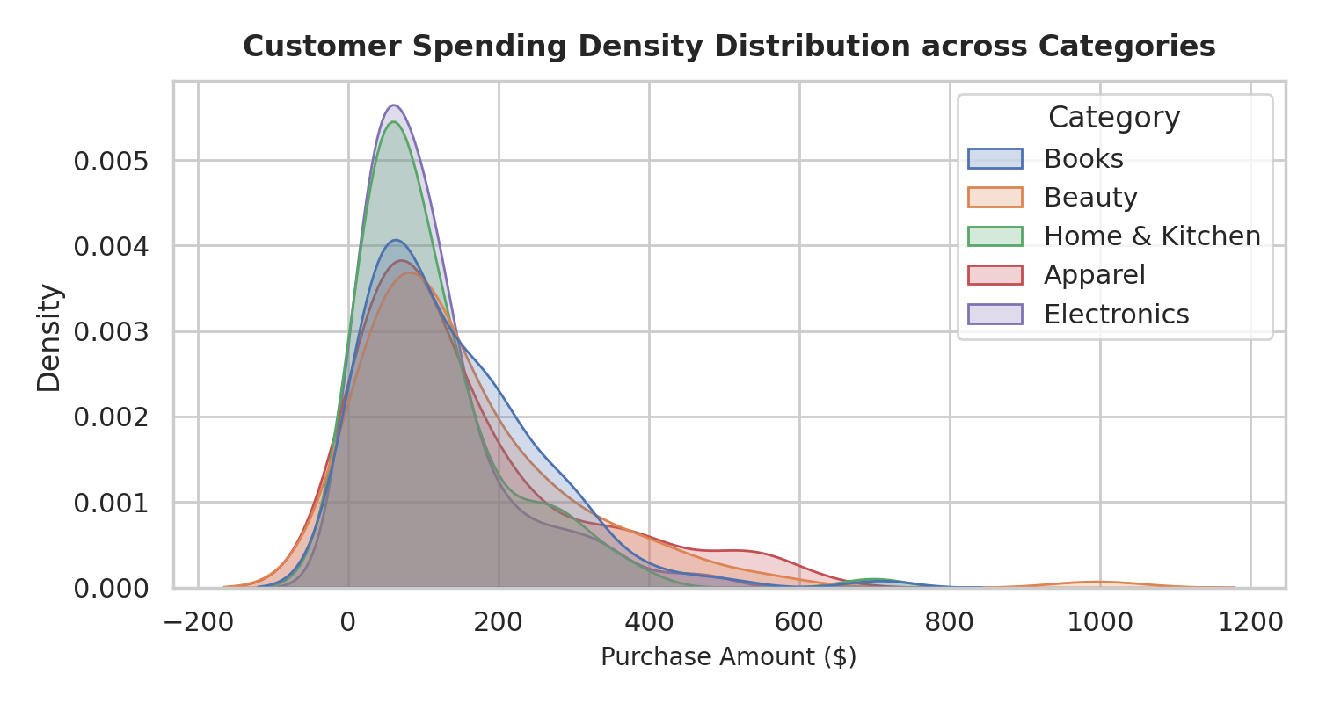
Figure: Task 2 - Kernel Density Estimation (KDE) of Spending Distribution
Task 3: University Examination Performance Dashboard
1. Python Code
import numpy as np
import pandas as pd
import matplotlib.pyplot as plt
import seaborn as sns
# Synthetic Examination Data
np.random.seed(101)
depts = ['Computer Science', 'Mechanical', 'Electrical', 'Civil', 'Biotech']
data = []
for dept in depts:
loc_val = {'Computer Science': 78, 'Mechanical': 62, 'Electrical': 68, 'Civil': 60, 'Biotech': 72}[dept]
scores = np.random.normal(loc=loc_val, scale=11, size=80)
scores = np.append(scores, [12, 18, 98, 100]) # Inject outliers
for s in scores:
data.append({'Department': dept, 'Score': np.clip(s, 0, 100)})
df_univ = pd.DataFrame(data)
# 1. Boxplot + Stripplot Overlay: Department Marks & Outliers
plt.figure(figsize=(8, 4.5))
sns.boxplot(data=df_univ, x='Department', y='Score', palette='mako', showfliers=True)
sns.stripplot(data=df_univ, x='Department', y='Score', color='black', alpha=0.35, jitter=0.2, size=4)
plt.title('Student Examination Marks & Outliers across Departments')
plt.ylabel('Marks Obtained (0-100)')
plt.tight_layout()
plt.show()
# 2. Score Distribution Histogram with KDE
plt.figure(figsize=(8, 4))
sns.histplot(data=df_univ, x='Score', hue='Department', kde=True, element='step', palette='turbo')
plt.title('Score Frequency Distribution by Department')
plt.xlabel('Marks Obtained')
plt.tight_layout()
plt.show()

2. Output Images
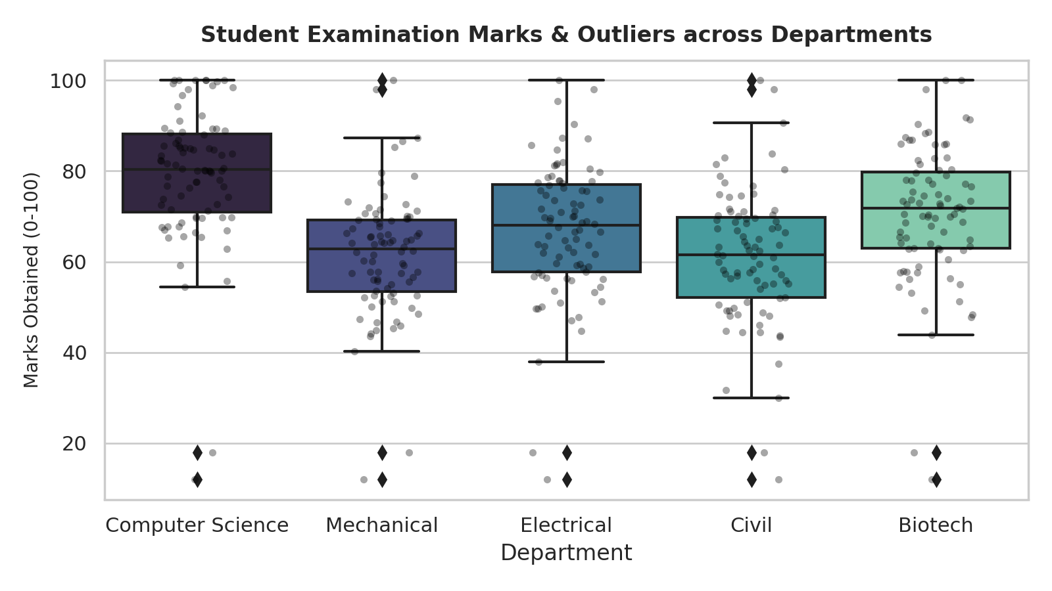
Figure: Task 3 - Box Plot with Stripplot Overlay showing Student Marks & Outliers
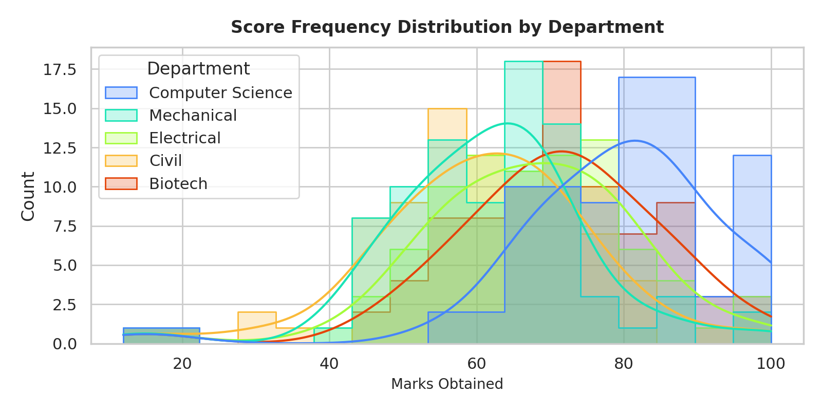
Figure: Task 3 - Score Frequency Distribution Histogram with KDE Curves
Task 4: Climate and Rainfall Distribution Study
1. Python Code
import numpy as np
import pandas as pd
import matplotlib.pyplot as plt
import seaborn as sns
# Synthetic Meteorological Data
np.random.seed(2024)
cities = ['City Alpha', 'City Beta', 'City Gamma']
months = ['Jan', 'Feb', 'Mar', 'Apr', 'May', 'Jun', 'Jul', 'Aug', 'Sep', 'Oct', 'Nov', 'Dec']
data = []
for c in cities:
for m in months:
if m in ['Jun', 'Jul', 'Aug', 'Sep']:
rf = np.random.gamma(shape=3 if c=='City Alpha' else 2, scale=35)
else:
rf = np.random.gamma(shape=1, scale=12)
temp = np.random.normal(loc=30 if m in ['May', 'Jun', 'Jul'] else 20, scale=2.5)
data.append({'City': c, 'Month': m, 'Rainfall_mm': rf, 'Temperature_C': temp})
df_climate = pd.DataFrame(data)
# 1. Box Plot: Seasonal Rainfall Variability
plt.figure(figsize=(7.5, 4))
sns.boxplot(data=df_climate, x='City', y='Rainfall_mm', palette='Set2')
plt.title('Rainfall Distribution & Variability across Cities')
plt.ylabel('Rainfall (mm)')
plt.tight_layout()
plt.show()
# 2. Density Plot (KDE): Climate Probability Distribution
plt.figure(figsize=(7.5, 4))
sns.kdeplot(data=df_climate, x='Rainfall_mm', hue='City', fill=True, palette='crest', alpha=0.3)
plt.title('Rainfall Probability Density Plot by City')
plt.xlabel('Rainfall (mm)')
plt.tight_layout()
plt.show()
# 3. Grouped Bar Chart: Monthly Seasonal Rainfall Pattern
plt.figure(figsize=(8.5, 4.5))
sns.barplot(data=df_climate, x='Month', y='Rainfall_mm', hue='City', palette='Blues')
plt.title('Monthly Seasonal Rainfall Trends across Cities')
plt.ylabel('Rainfall (mm)')
plt.tight_layout()
plt.show()

2. Output Images
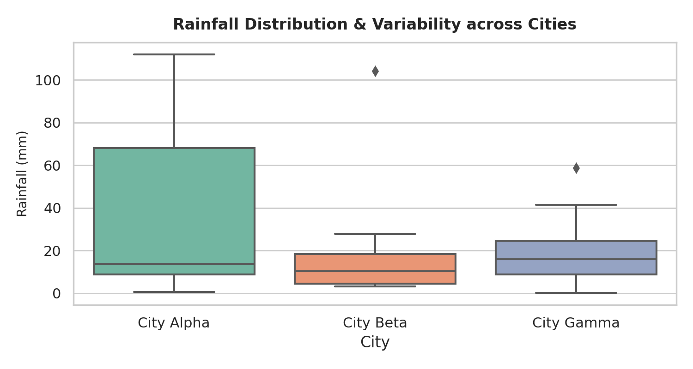
Figure: Task 4 - Seasonal Rainfall Box Plot by City
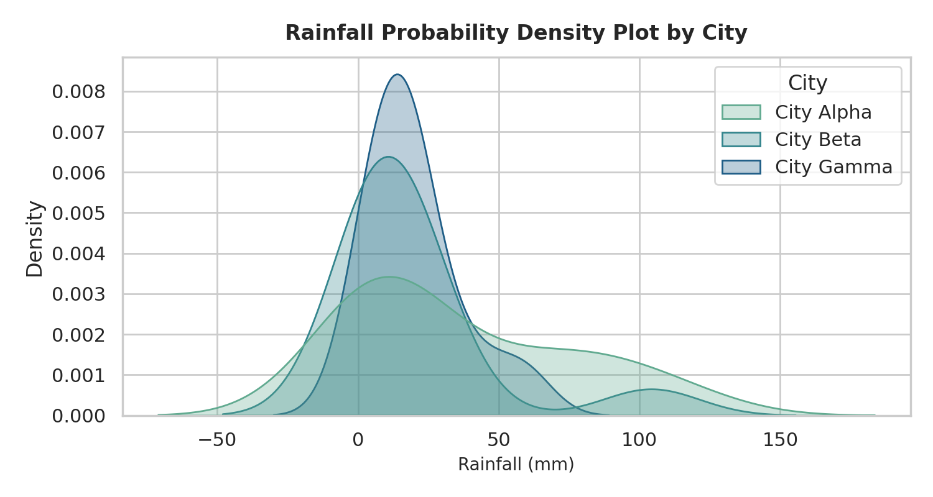
Figure: Task 4 - Rainfall Probability Density Plot (KDE)
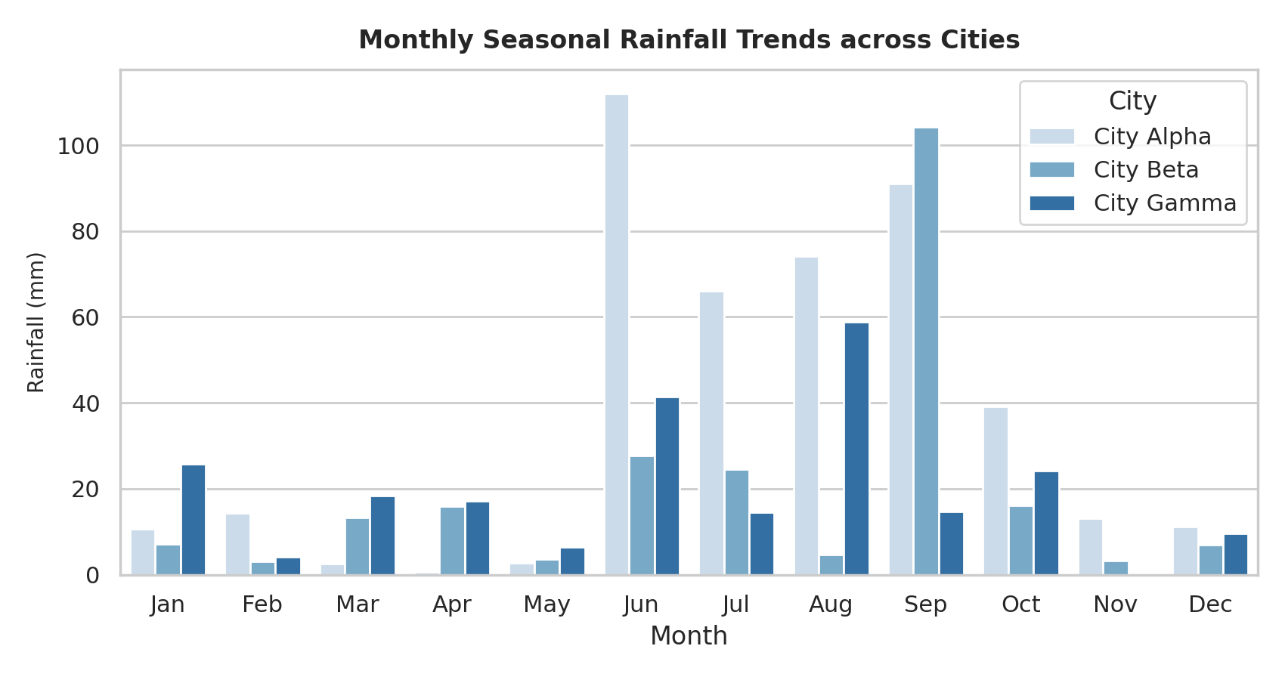
Figure: Task 4 - Grouped Bar Chart showing Monthly Seasonal Trends
Task 5: Bank Loan Risk Assessment
1. Python Code
import numpy as np
import pandas as pd
import matplotlib.pyplot as plt
import seaborn as sns
# Synthetic Banking Loan Data
np.random.seed(777)
n_loans = 600
df_bank = pd.DataFrame({
'LoanAmount': np.random.lognormal(mean=10.2, sigma=0.75, size=n_loans),
'Income': np.random.lognormal(mean=10.8, sigma=0.55, size=n_loans),
'CreditScore': np.random.randint(550, 850, size=n_loans),
'RiskStatus': np.random.choice(['Low Risk', 'High Risk'], size=n_loans, p=[0.75, 0.25])
})
# 1. Histogram: Loan Amount Skewness & Risk Segmentation
plt.figure(figsize=(7.5, 4))
sns.histplot(data=df_bank, x='LoanAmount', hue='RiskStatus', kde=True, bins=30, palette='magma')
plt.title('Loan Amount Skewness & Distribution by Risk Status')
plt.xlabel('Loan Amount ($)')
plt.tight_layout()
plt.show()
# 2. Box Plot: Risk Category Outliers
plt.figure(figsize=(7.5, 4))
sns.boxplot(data=df_bank, x='RiskStatus', y='LoanAmount', palette='Set1')
plt.title('Loan Amount Distribution & Outliers by Risk Group')
plt.ylabel('Loan Amount ($)')
plt.tight_layout()
plt.show()
# 3. Log-Scale Scatter Plot: Income vs. Loan Amount & Credit Score
plt.figure(figsize=(8, 4.5))
sns.scatterplot(
data=df_bank,
x='Income',
y='LoanAmount',
hue='RiskStatus',
size='CreditScore',
sizes=(20, 120),
palette={'Low Risk': '#2ecc71', 'High Risk': '#e74c3c'},
alpha=0.7
)
plt.xscale('log')
plt.yscale('log')
plt.title('Income vs. Loan Amount (Log Scale) by Risk & Credit Score')
plt.xlabel('Income ($ - Log Scale)')
plt.ylabel('Loan Amount ($ - Log Scale)')
plt.tight_layout()
plt.show()

2. Output Images
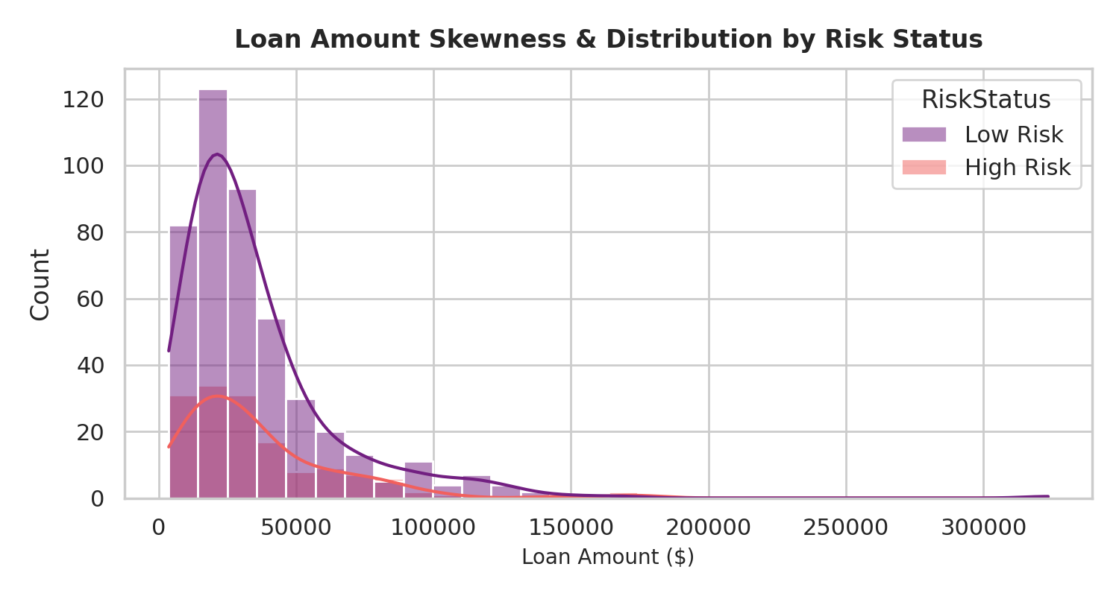
Figure: Task 5 - Loan Amount Skewness Histogram with Risk Overlay
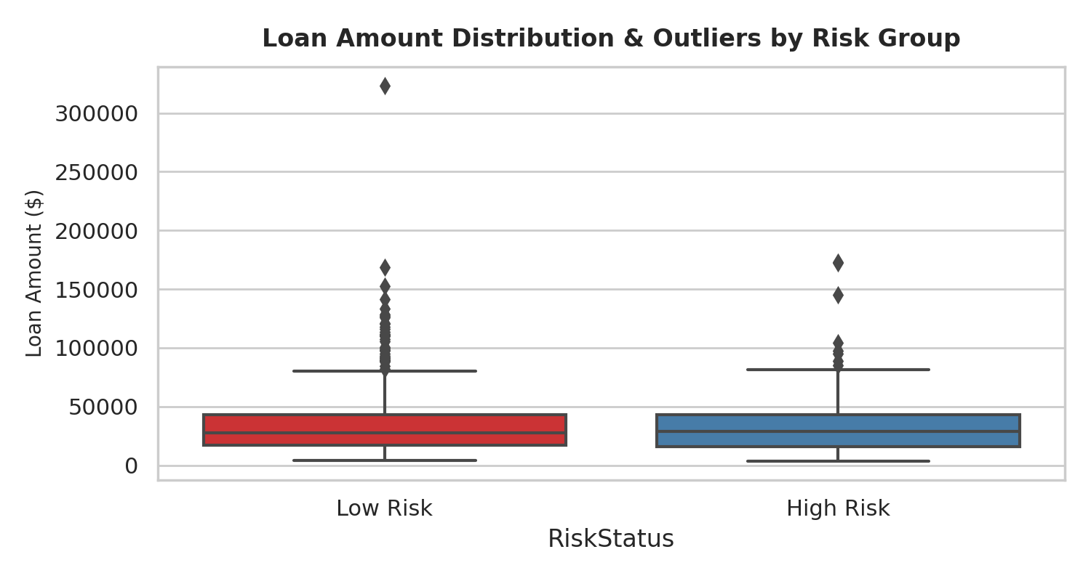
Figure: Task 5 - Box Plot of Loan Amounts & High-Risk Outliers
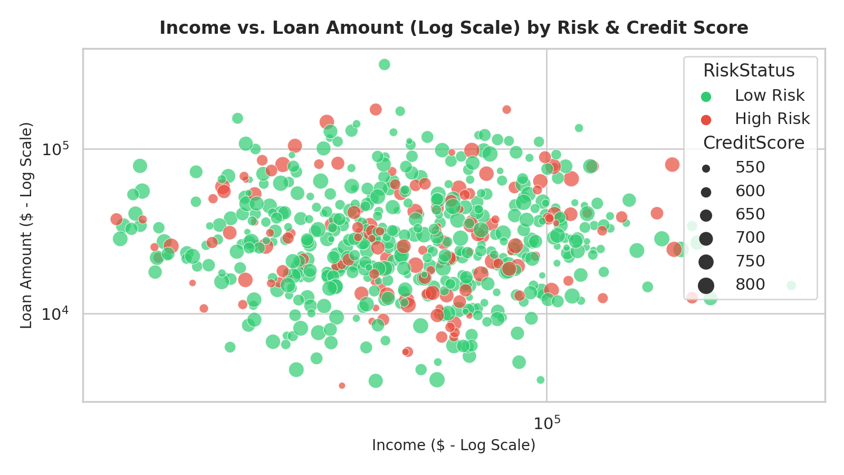
Figure: Task 5 - Log Scatter Plot (Income vs. Loan Amount by Risk & Credit Score)

